Friday 20th September 2024

Dear parents/carers,

I am delighted to share that to mark the beginning of ‘World Space Week’, on the 4th October, we will be delivering a space event in school.

This will involve having a ‘Space Dome’ (a large inflatable plenatarium) in school, providing an immersive space experience for those inside. All classes from Nursery to Year 6 will have the opportunity to visit the space dome for an age - appropriate session.

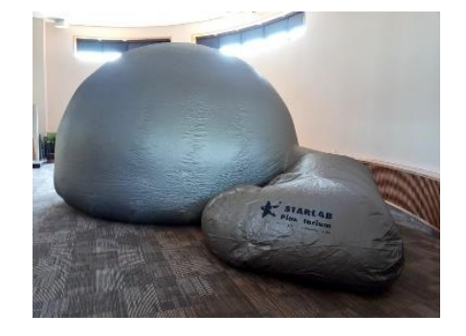
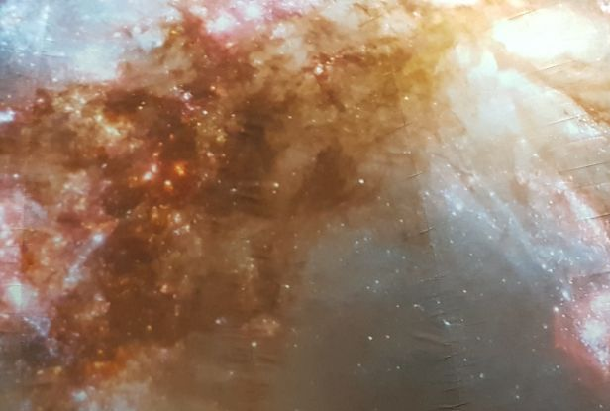
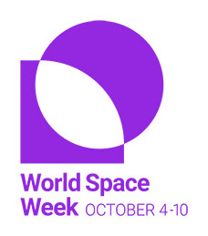

In order to provide this exciting experience for pupils, a large area of the hall space will be occupied by the space dome. There will therefore be some alternate lunch time arrangements on this day.

This includes:

Year 1 to Year 6 eating their lunch in class.

Lunch time options differing slightly to those listed on the school menu for this day only.
Pupils will be able to choose from a sandwich or pizza option, with a side option and pudding.
Pupils who usually bring a lunch box should do so as usual.

If you have any concerns about the food options available on this day, please speak to your child’s class teacher as soon as possible so that we can arrange an alternate option with the kitchen team.

There will also be no celebration assembly in the hall on this day and certificates will be awarded in class.

We look forward to celebrating World Space Week in school!

Miss Bridges (Science Lead)

