Outdoor physical activities
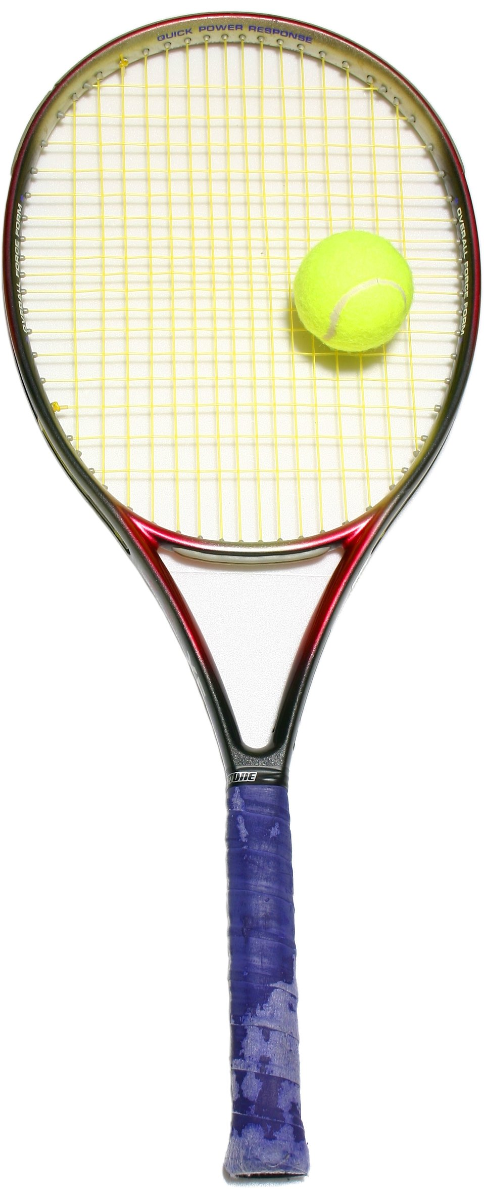

Up and under


- Use paper / plastic dishes that you may have in your house. Spread the bowls around, turn some upside down and the others the right way up.
- Have 2 x teams or 1 v 1.
- When you shout ‘GO’, 1 team turns the bowls the right way up, the other team turn them upside down.
- When you shout ‘STOP’ count how many are upside down & how many are the right way up. The winning team is the one with the most.

- Name 4 corners of your garden, using your children’s favourite things e.g. cartoon characters, superheroes. You could ask the children to draw pictures and place these in the corners as markers.
- Shout out 1 of the names and get all of the children to walk to that corner. Do this as a practice.
- Shout a different name and ask the children to hop to that corner.
- Shout another name and ask the children to jump to that corner.
- You could introduce that the last person there is out if you wanted to make it competitive.
- Introduce all kinds of movements to get to the corner – on all 4’s like a crab, backwards, sideways, star jumps etc.

Beans

- Go through different kinds of ‘beans’, real & make believe and get the children to practice their actions:

Type of ‘bean’ | Action
Runner bean | Run on the spot
Jumping bean | Jump on the spot
Baked bean | Lie on the floor and sunbathe
Bean sprout | Stand on tiptoes & make yourself as tall & thin as possible
Jelly bean | Wobble like jelly on a plate
Broad bean | Spread out wide with your arms and legs
Baby bean | Lie on the floor and crouch like a baby
French bean | All say ‘bonjour’ in a French accent
Magic bean | Wave your magic wand
Mean bean | Make an angry face
Boogie bean | Dance around

- Shout out different ‘beans’ and all do the actions.

- Shout out different ‘beans’ and get children to follow the action.


Here, there & everywhere

- Use a scarf, sock or other similar household object; tuck it into the top of your trousers at the back, to make a ‘tail’.
- Move around the garden protecting your ‘tail’ from others. You cannot touch your own tail or hold it to stop others catching it.
- The aim of the game if to chase each other around and try to steal other children’s tails.
- If you steal a tail, double yours up so you have 2.
- If a ‘tail’ falls onto the floor the one who gets it claims it.

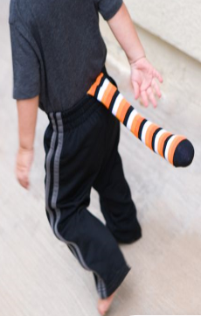
Catch a tiger’s tail

- Draw a line down the middle of the garden or use a piece of string to mark this out.
- Ask all of the children to stand on the line.
- Shout out 2 x things, pointing one side of the line for one answer and the other side for the second e.g. Toast or cereal? Green or blue? Bath or shower?
- Ask children to choose their favourite & run to that side.
- Great for British values and making choices.
Where do you stand?
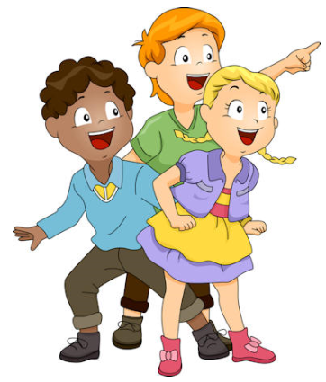

- Use a chalk board or paper and write a list of objects that the children have to find around the garden.
- Try to think of really unusual things to make it harder.
- Children can race against each other to see who can find them all first.
Scavenger hunt
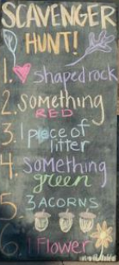
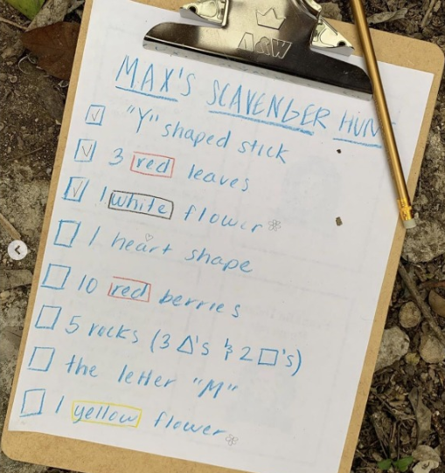

- Choose 1 person to be the farmer. They stand in the middle of the garden. Everyone else stands facing them at the edge.
- Everyone asks ‘farmer farmer, may we cross your golden field of corn’? The farmer says ‘only if you are …………….’ then makes up something like if you are wearing green or if your name has an A in it etc….
- Everyone who meets this can cross the field.
- The farmer then says go and everyone else has to try and run across to the other side without the farmer catching them. If they get caught they have to stand in the middle with the farmer.
- Start again but this time with extra farmers if some have been caught.

Farmer farmer

