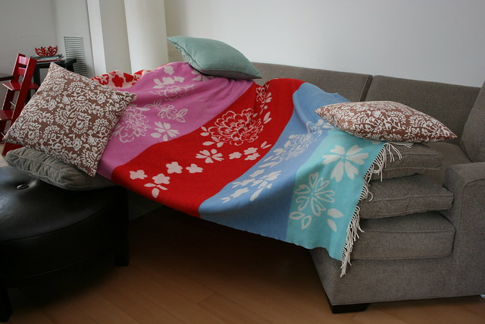
Den building
Many wonderful moments can be shared when we encourage our little ones (and big ones) to build dens either outdoors in this lovely sunshine or indoors in a secure corner of a room or creating a sleepover pod, the ideas are limitless, let your imaginations run wild with just a few resources to hand.

Benefits
Den building brings not only hours of fun; it sparks imagination,
helps children to solve problems, lends itself to role play and offers fresh air
and exercise outdoors, but it also gives great learning and development opportunities
Whilst having all this fun creating a den, you can chat about the building of the den and challenges you may come up with and also it is a time to chat with your child about anything they choose, within a different environment, and once the den is built it’s the perfect place to share a book with a special loved one, make up magical moments, create further adventures or chat about anything worrying your child.
Hiding is adventurous! Building a den offers a child the chance to hide away and a sense of privacy to have their own thoughts. (Obviously supervision is still needed even if they think you’re not aware of where they are!).
Where can I build a den? Almost anywhere; in a corner of a garden, under a table, round a tree….
Just about anywhere so long as your little one (or big one) is safe
Cardboard box den Cardboard boxes are so versatile and can be made into so many different things.
If you don’t have a large box 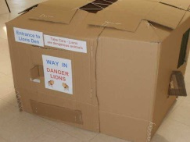 then you could stack fruit boxes 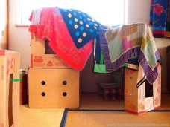 (usually found in supermarkets for free) or cut up and use separate bits joined together! 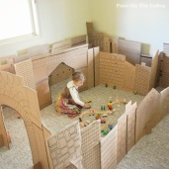
Tepee style Den Outdoors gives children the opportunity to use natural resources to make and decorate their den by e.g. using branches, twigs, flowers and leaves 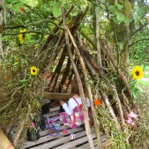 or garden canes. 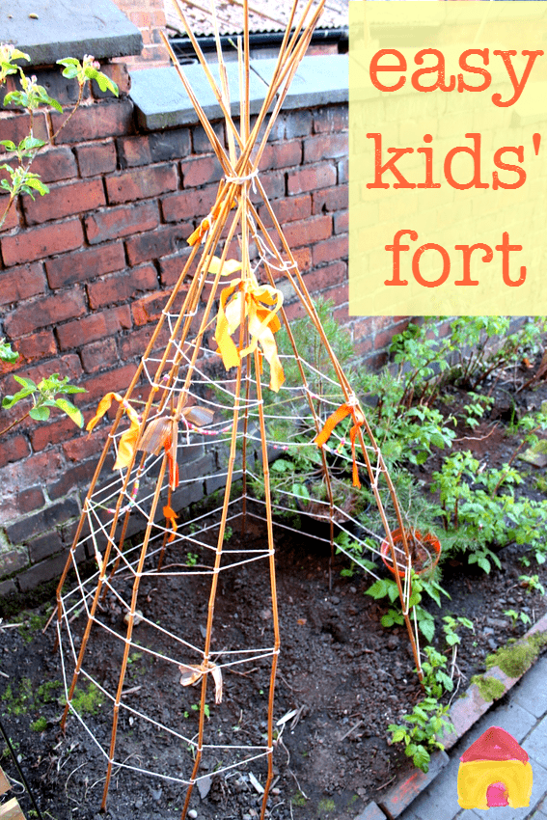 You can use string and other materials to weave with. (Word of advice -ensure the top is securely fastened to prevent it toppling!)
Hoola hoop den A resource your child may have to hand, why not turn this into a tranquil place for one or two children 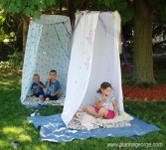or a secret spy den by adding twigs and leaves 
A basic method would be to add string at points of the hoop joined together to hang it with. Then use a large piece of material e.g. bed sheet/shower curtain to go round the hoop and tape this into place. A more detailed method is included via a link at the end of this sheet.
Garden furniture den E.g. parasol 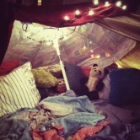 a rotary dryer 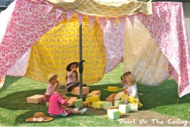 or washing line 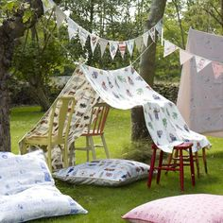
Covers and cushions den This could be old blankets, sheets, canvas 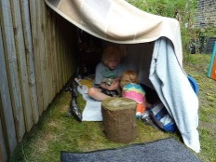and a pile of cushions to make a cushion cave or pillow pit 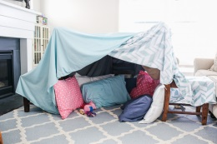
Under a table Den You may have a table indoors or outside that can be instantly transformed into a den 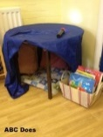 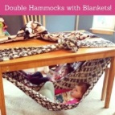
Trampoline den 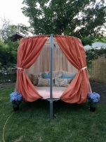 It doesn’t need to be this big or fancy just safe od
Warning - Do not use underneath of trampoline, unless you are sure no-one will jump on it!
A long term project maybe for when we are all back to normal - 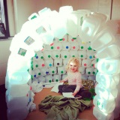 Start collecting your milk bottles (
Soooo many examples can be found on google images:
Dens can range from the most simple 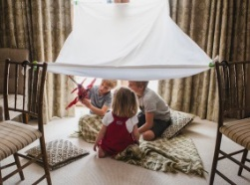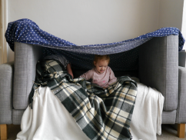 to the most fancy 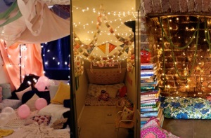
Dens for just one child, 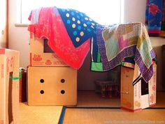 a few children, 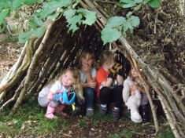
or the whole family 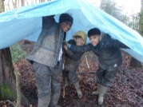 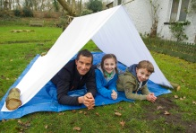 
Themed dens for example:
Sensory; with the addition of safe soft lighting, different textures, blanket or cover, toys to ‘fidget’ with or a teddy or favourite snuggly to share a cuddle with;
Musical, with either bought or made instruments to share music making together to maybe put on a ‘mini performance’;
Reading, by themselves or sharing with someone, time in a den away from distractions can really support with reading and storytelling;
Role play for example 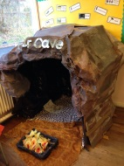 is such fun and can be done so simply, you don’t have to think big and ‘Ta dah’, it can be left to the child’s imagination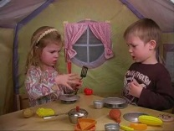 with you on hand to help if needed, or left for open ended play 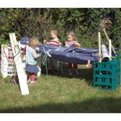 which could turn into anything ! Let their imaginations go wild.
Hopefully you will now be able to find that inner Dengineer. Don’t forget you can transform what you already have quite easily with a few resources to hand e.g:
Fixers – anything to hold things together such as string, tape, ribbon, clothes pegs…

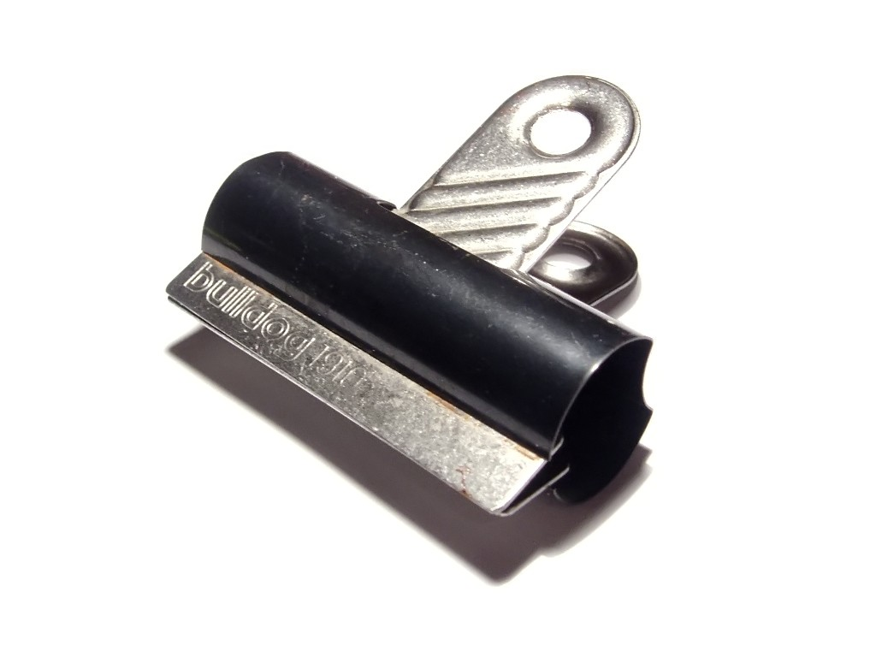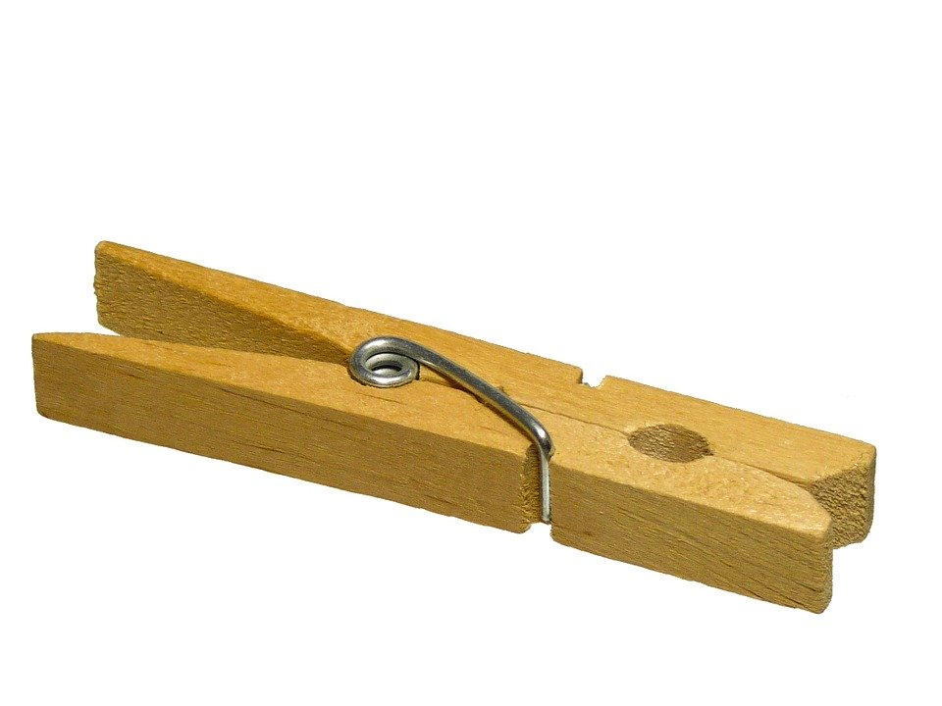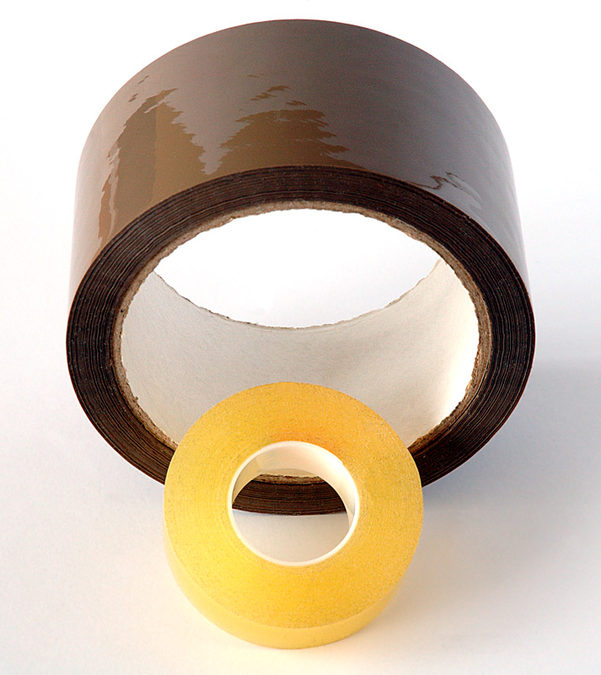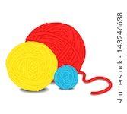

Decorations - personalise dens with paints, chalks, ribbons, leaves, flowers etc.
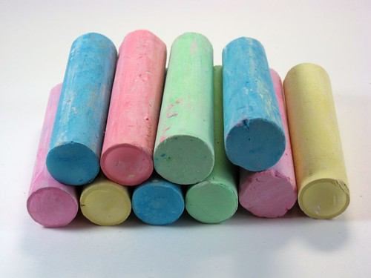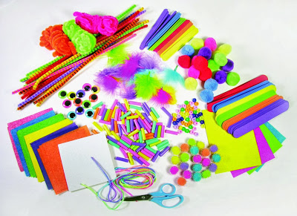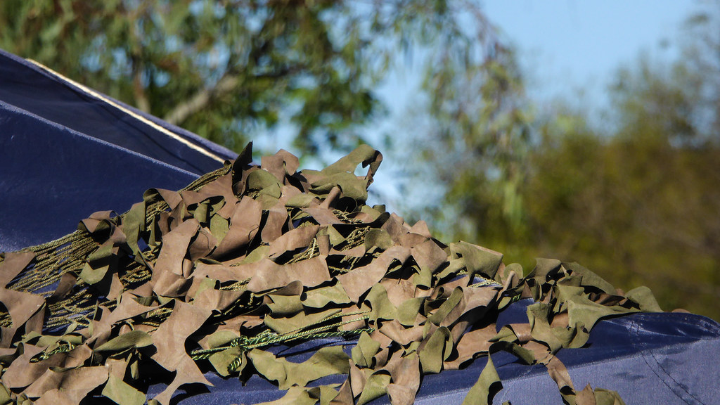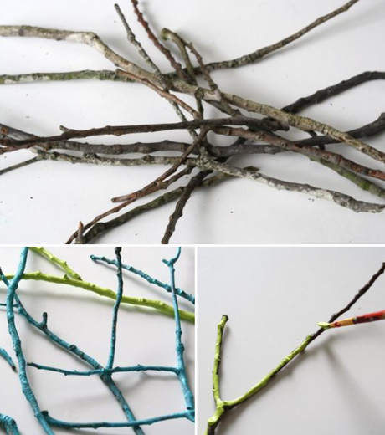

You may want to start small or fancy creating smaller dens for an imaginary friend or special someone….
why should they miss out on all the fun?
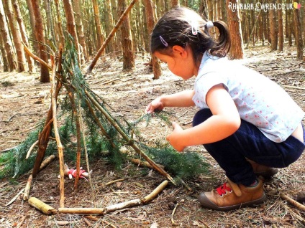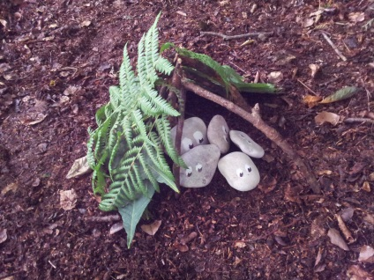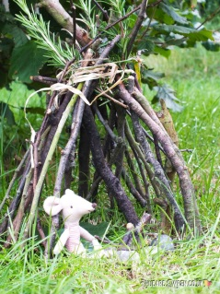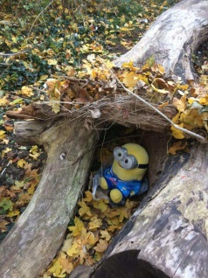

And remember …
At times like these
treat yourself to a special moment
in a special place just for you,
wherever that may be.

Further information available from:
- Building a Den, keep the children busy for hours available from:
https://www.actionforchildren.org.uk/support-for-parents/top-5-tips-for-den-building-with-your-children/
Written by Pentagon for learning and play.
- Loads of further extension ideas and related posts from: https://www.earlyyearsresources.co.uk/blog/2018/06/top-den-building-play-activities/
- For the more adventurous who want to build a more permanent hoola hoop tent and have the time, materials and tools and possibly patience go to: https://www.wikihow.com/Make-a-Hula-Hoop-Tent
- GoodToKnow - The 17 most incredible homemade dens we’ve ever seen available from:
https://www.goodtoknow.co.uk/family/best-homemade-dens-98004

PLEASE SEE BELOW FOR INFORMATION ABOUT:

FAMILY DEN DAY
Do you feel you could be a Dengineer!!
Do you want to help ‘Save the Children’ by getting involved or want to visit their website for lots of other useful information for older children about how they can support the charity. Please visit https://www.savethechildren.org.uk/how-you-can-help/events-and-fundraising/den-day/schools-downloads and download lots of useful resources and share something great
Lots more simple ideas from Save the Children’s Den Day – available at: https://www.pinterest.co.uk/savechildrenuk/den-day-lets-build-a-better-world/
Have fun and good luck!

