Newman Catholic Collegiate Dictionary

KS4

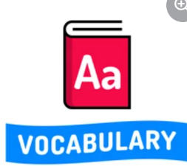

Tier 2
Term | Definition
Coherent | Making sense; able to be understood.
Critical | Giving opinions or judgments
Evaluate | To judge the importance of something.
Infer | An idea that you form based on the information given.
Judicious | Showing good judgment when making decisions.
Patriarchal | Ruled or controlled by men.
Perceptive | Very good at noticing and understanding things that many people do not notice.
Perspective | A point of view or way of considering something.
Stereotype | A set idea that people have about what someone or something is like.
Synthesise | Combining information from more than one source.

Tier 3
Term | Definition
Allusion | Something that is said or written that is intended to make you think of a particular thing or person.
Caesura | A pause or full stop in the middle of a line of poetry.
Cyclical Cycle | When things ‘come around full circle’ or seem to return to the way they were at the beginning.
Dramatic Irony | When the audience know something that the characters do not.
Enjambment | When a sentence in a poem continues over a ‘line break’ or gap.
Foreboding | When something that happens earlier in a text is a clue or reflection of something bad that will happen later.
Semantic Field | A range of words that all relate to the same topic or idea.
Soliloquy | A character making a speech alone on stage, to reveal their thoughts in front of the audience
Sonnet | A 14-line love poem with an ABAB rhyme scheme. It ends in a rhyming couplet and uses iambic pentameter.
Withholding Information | Deliberately keeping information from the audience so that it can be revealed in a twist or shocking moment later.

