Newman Catholic Collegiate Dictionary

KS3

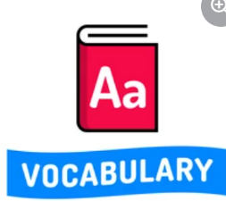

Tier 2
Term | Definition
Analyse | To study or examine something in detail in order to discover or understand more about it.
Context | The time period, circumstances and events in society that have led to the text being written.
Describe | To say or write what someone or something is like.
Effect | What a writer is trying to convey or make a reader think, feel or imagine.
Embedded (relating to a quotation) | To fix a quotation firmly into a sentence.
Explicit | Clear and exact.
Implicit | Suggested, but not communicated directly.
Persuade | To make someone do or believe something by giving them a good reason to do it or by talking to that person and making them believe it.
Purpose | The reason why something has been done or produced.
Summary | Brief and clear statements that give the most important facts about something.

Tier 3
Term | Definition
Antagonist | A character in a story who is presented as the chief enemy (foe) of the protagonist.
Direct Address | Directly talking to the reader by using the pronoun ‘you’
Emotive Language | Words or phrases that encourage the reader to feel a particular emotion.
Foreshadowing | When something that happens earlier in a text is a clue or reflection of something that will happen later.
Juxtaposition | When two opposites are described next to each other, to make their differences stand out.
Motif | An idea or image that is repeated many times.
Oxymoron | Two words or phrases used together that have, or seem to have, opposite meanings.
Plosives | Repeated ‘p’, ‘b’ or ‘d’ sounds within words.
Sibilance | Repeated ‘s’ sounds within words.
Symbol | When an object is used to represent something else.

