Newman Catholic Collegiate Dictionary

KS2

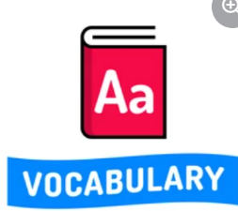

Tier 2
Term | Definition
Compare | To look for the difference between two or more things.
Explain | To make something easy to understand by describing or giving information about it.
Evidence | Anything that helps to prove if something is or is not true.
Fact | Something that is known to have happened or to exist.
Formal | Using an agreed and often official or traditional way of doing things.
Inference | A guess that you make or an opinion that you form based on the information that you have.
Impression | An idea or opinion of what something or someone is like.
Justify | To show that something is reasonable, right, or true.
Opinion | A thought or belief about something or someone.
Persuade | To make someone do or believe something by giving them a good reason to do it or by talking to that person and making them believe it.
Suggest | To communicate or show an idea or feeling without stating it directly.
Summarise | To express the most important facts or ideas about something.

Tier 3
Term | Definition
Ambiguity | Something that is unclear because it can be understood in more than one way.
Clause | A group of words containing a verb.
Conjunction | A word that connects words, phrases and clauses in a sentence.
Draft | The first attempt of a piece of writing.
Edit | To make changes to a text.
Emotive language | Words that cause strong feelings.
Figurative language | Words used not with their basic meaning but with a more imaginative meaning.
Parenthesis | Punctuation used to mark extra information in a sentence
Passive Voice | Where the subject of a sentence receives the action of the verb.
Personification | Giving a human quality to something that is not human.
Pronoun | A word that is used instead of a noun or noun phrase.
Quotation | A phrase or short piece of writing taken from another text.
Simile | Comparing one thing to another, using the words ‘as’ and ‘like’.
Synonym | A word or phrase that has a similar meaning to another word or phrase.

