Newman Catholic Collegiate Dictionary

KS1

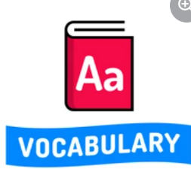

Tier 2
Term | Definition
Describe | Telling you what someone or something is like.
Discuss | To share with others your ideas or views.
False | Not real or true.
Information | Facts about a something or someone.
Non-fiction | Factual text (not a story)
Order | To put something in its correct place.
Predict | To say what you think will happen.
Report | To give information about something for someone.
Rewrite | To write something again
True | Something that is right and correct.

Tier 3
Term | Definition
Adjective | A word used to describe a noun or pronoun.
Adverb | A word that describes or gives more information about a verb, adjective or phrase.
Alliteration | The same sounds used at the beginning of words which are close together.
Character | A person represented in a film, play, or story.
Command | A sentence which starts with an imperative (bossy) verb.
Exclamation | A sentence beginning with ‘What’ or ‘How’ followed by a noun and verb to show strong emotion.
Noun | A naming word
Tense | This shows the time when an action happened.
Verb | A doing or being word

