Newman Catholic Collegiate Dictionary
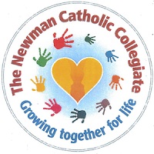
EYFS

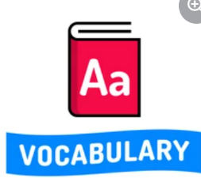

Tier 2
Term | Picture | Definition
Book | 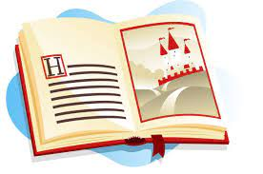 | Words and pictures on a page which we read.
Draw | 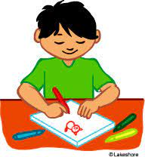 | To make a picture of something or something.
Label | 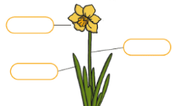 | To write information on something.
Name |  | The word that a person, thing or place is known by.
Page | 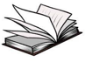 | A piece of paper in a book with words and pictures on.
Picture |  | A drawing, painting or photograph in a book.
Read | 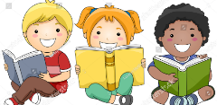 | To say words that are written
Talk | 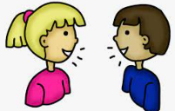 | To say words aloud.
Text | 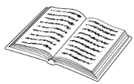 | The written words in a book.
Write | 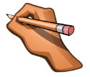 | To make marks which show meaning.

Tier 3
Term | Picture | Definition
Alphabet | 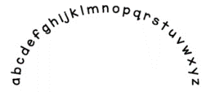 | 26 letters in order from A to Z.
Author | 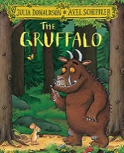 | The writer of a book.
Fiction | 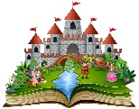 | A made up story.
Grapheme | 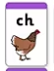 | A letter or letters that match a phoneme in a word.
Letter | 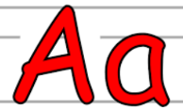 | A to Z written down to match sounds
Phoneme | 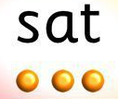 | A sound.
Rhyme | cat  rat | A word that has the same last sound as another word.
Sentence | I went to the park. | A group of words put together which make sense.
Sound | 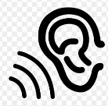 | Something which you can hear.
Title |  | The name of a book.

